**Drop Down:**

package demo;

import org.openqa.selenium.By;

import org.openqa.selenium.WebElement;

import org.openqa.selenium.chrome.ChromeDriver;

import org.openqa.selenium.support.ui.Select;

public class DropDownDemo {

public static void main(String args[]) {

ChromeDriver driver = new ChromeDriver();

driver.manage().window().maximize();

driver.get("https://letcode.in/dropdowns" );

WebElement languages = driver.findElement(By.id("lang"));

Select select = new Select(languages);

select.selectByVisibleText("Java");

}

}

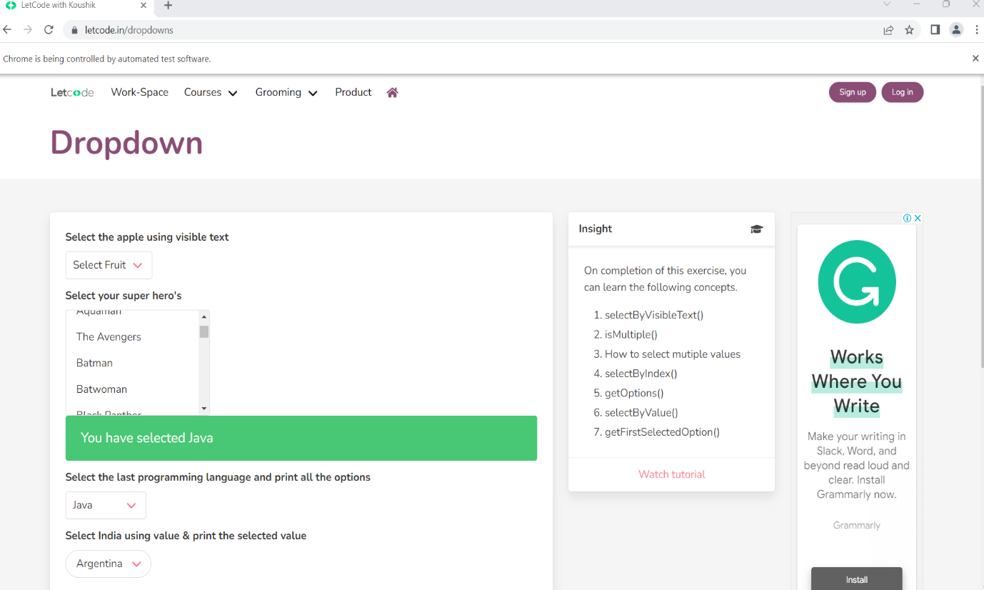

**Verify Error Message:**

package demo;

import org.openqa.selenium.By;

import org.openqa.selenium.chrome.ChromeDriver;

public class VerifyErrorMessage {

public static void main(String[] args) {

// 1) Open the browser

ChromeDriver driver = new ChromeDriver();

// 2) Navigate to application

driver.get("https://facebook.com");

// 3) Enter invalid username 'batman554466@gmail.com' in the 'Email address or phone number' textbook

driver.findElement(By.id("email")).sendKeys("batman554466@gmail.com");

// 4) Enter invalid password 'password@123' in the 'Password' textbook

driver.findElement(By.id("pass")).sendKeys("password@123");

// 5) Click Login button

driver.findElement(By.name("login")).click();

// 6) Verify user sees the error message - "The email address you entered isn't connected to an account. Find your account and log in".

String expectedErrMsg = "The email address you entered isn't connected to an account. Find your account and log in.";

//String actualErrMsg = driver.findElement(By.cssSelector("#email_container > div._9ay7")).getText();

String actualErrMsg = driver.findElement(By.cssSelector("#email_container > div._9ay7")).getText();

if(expectedErrMsg.equals(actualErrMsg)) {

System.out.println("Test Case Passed");

}

else {

System.out.println("Test Case Failed");

}

// 7) Close the browser

driver.quit();

}

}

**Output:**

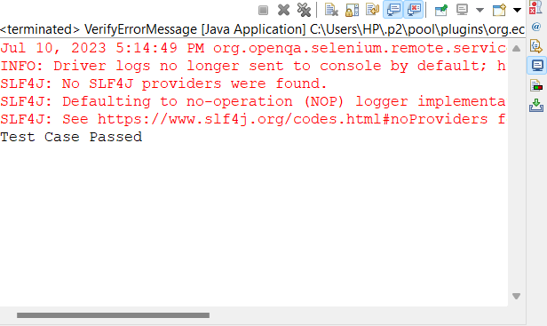

**Explicit Wait Demo:**

package demo;

import java.time.Duration;

import org.openqa.selenium.By;

import org.openqa.selenium.chrome.ChromeDriver;

import org.openqa.selenium.support.ui.ExpectedConditions;

import org.openqa.selenium.support.ui.WebDriverWait;

public class ExplicitWaitDemo {

public static void main(String args[]) {

ChromeDriver driver = new ChromeDriver();

driver.manage().window().maximize();

driver.get("https://whitecircleschool.com/explicit-wait-demo/");

driver.findElement(By.id("start")).click();

String expectedText = "Hello World!";

WebDriverWait wait = new WebDriverWait(driver, Duration.ofSeconds(60));

wait.until(ExpectedConditions.visibilityOfElementLocated(By.cssSelector("#finish > h4")));

String actualText = driver.findElement(By.cssSelector("#finish > h4")).getText();

if(actualText.equals(expectedText)) {

System.out.println("Test Case Passed");

}

else {

System.out.println("Test Case Failed");

}

driver.quit();

}

}

**Output:**

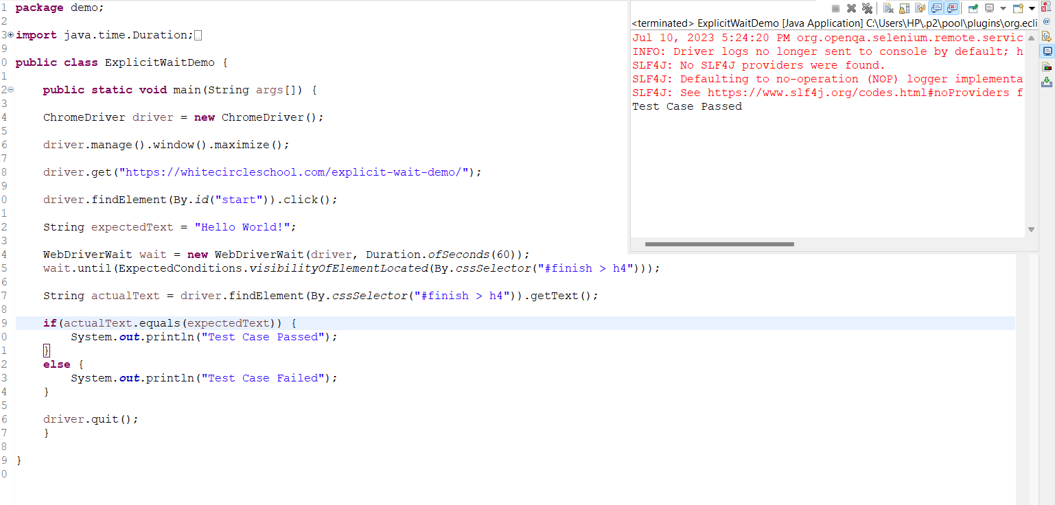

**WebTable Demo:**

package Demo ;

import java.util.List;

import org.openqa.selenium.By;

import org.openqa.selenium.WebElement;

import org.openqa.selenium.edge.EdgeDriver;

public class TableDemo {

public static void main(String[] args) {

EdgeDriver driver = new EdgeDriver();

driver.manage().window().maximize();

driver.get("https://letcode.in/table");

WebElement firstTable = driver.findElement(By.id("shopping"));

List<WebElement> rows = firstTable.findElements(By.tagName("tr"));

int sum = 0;

for (int i = 1; i < rows.size(); i++) {

WebElement row = rows.get(i);

List<WebElement> columns = row.findElements(By.tagName("td"));

int price = Integer.parseInt(columns.get(1).getText());

sum = sum + price;

}

int expectedSum = 858;

if (expectedSum == sum) {

System.out.println("Test Case Passed");

} else {

System.out.println("Test Case Failed");

}

driver.quit();

}

}

**Output:**

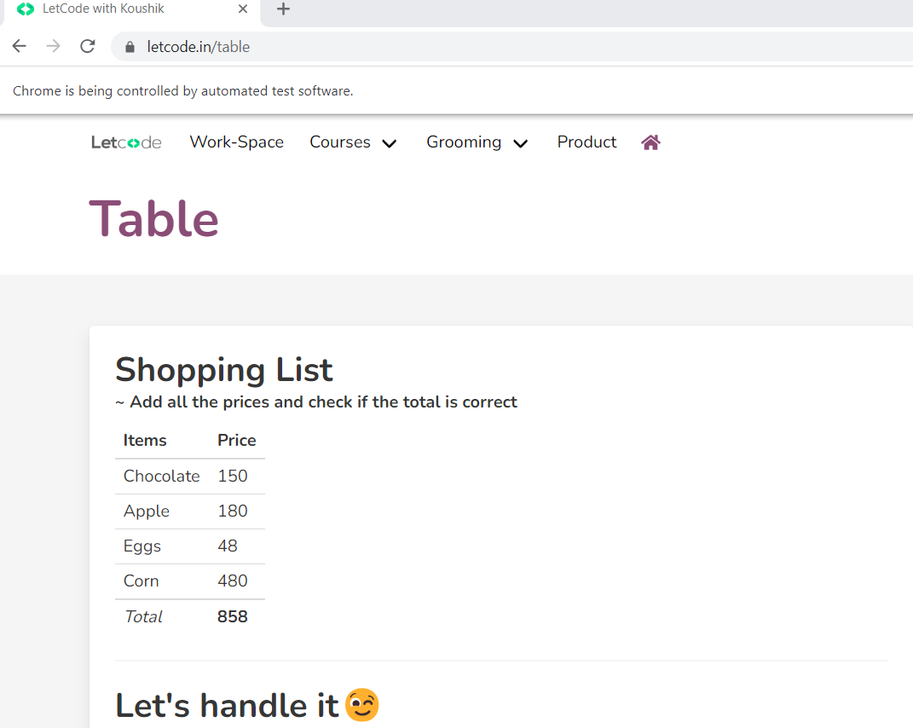

**RadioButton and CheckBoxes:**

package demo;

import org.openqa.selenium.By;

import org.openqa.selenium.chrome.ChromeDriver;

public class RadioBtnAndCheckBoxes {

public static void main(String args[]) {

ChromeDriver driver = new ChromeDriver();

driver.manage().window().maximize();

driver.get("https://letcode.in/radio");

driver.findElement(By.id("yes")).click();

driver.findElement(By.xpath("//input[contains(@type, 'checkbox')])[2]")).click();

}

}

**Output:**

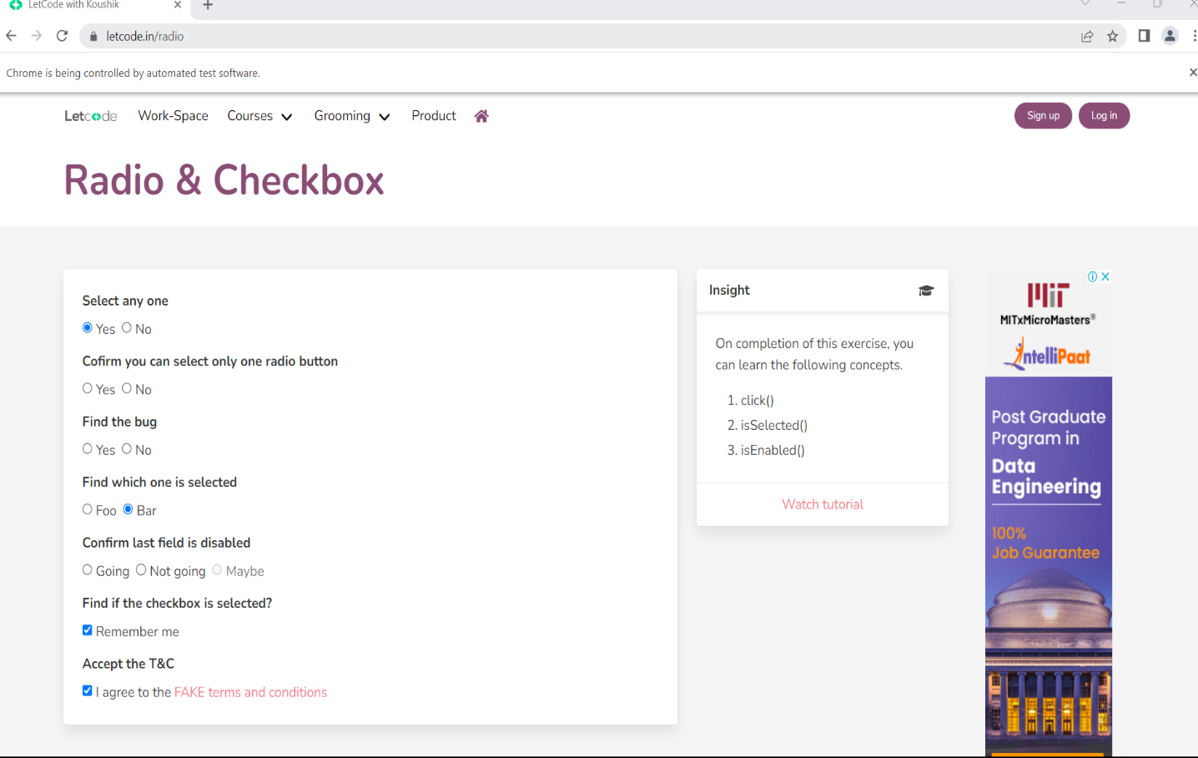

**AlertBoxDemo:**

package Demo;

import org.openqa.selenium.By;

import org.openqa.selenium.edge.EdgeDriver;

public class AlertMessage {

public static void main(String[] args) throws InterruptedException {

// 1)open the browser

EdgeDriver driver = new EdgeDriver();

// 2) maximize it

driver.manage().window().maximize();

// 3)navigate to application

driver.get("https://retail.onlinesbi.sbi/retail/login.htm");

// 4) click on continue to login button

driver.findElement(By.linkText("CONTINUE TO LOGIN")).click();

// 5) click on login button

driver.findElement(By.id("Button2")).click();

Thread.sleep(3000);

// 6) close the alert box

driver.switchTo().alert().accept();

}

}

**Output:**

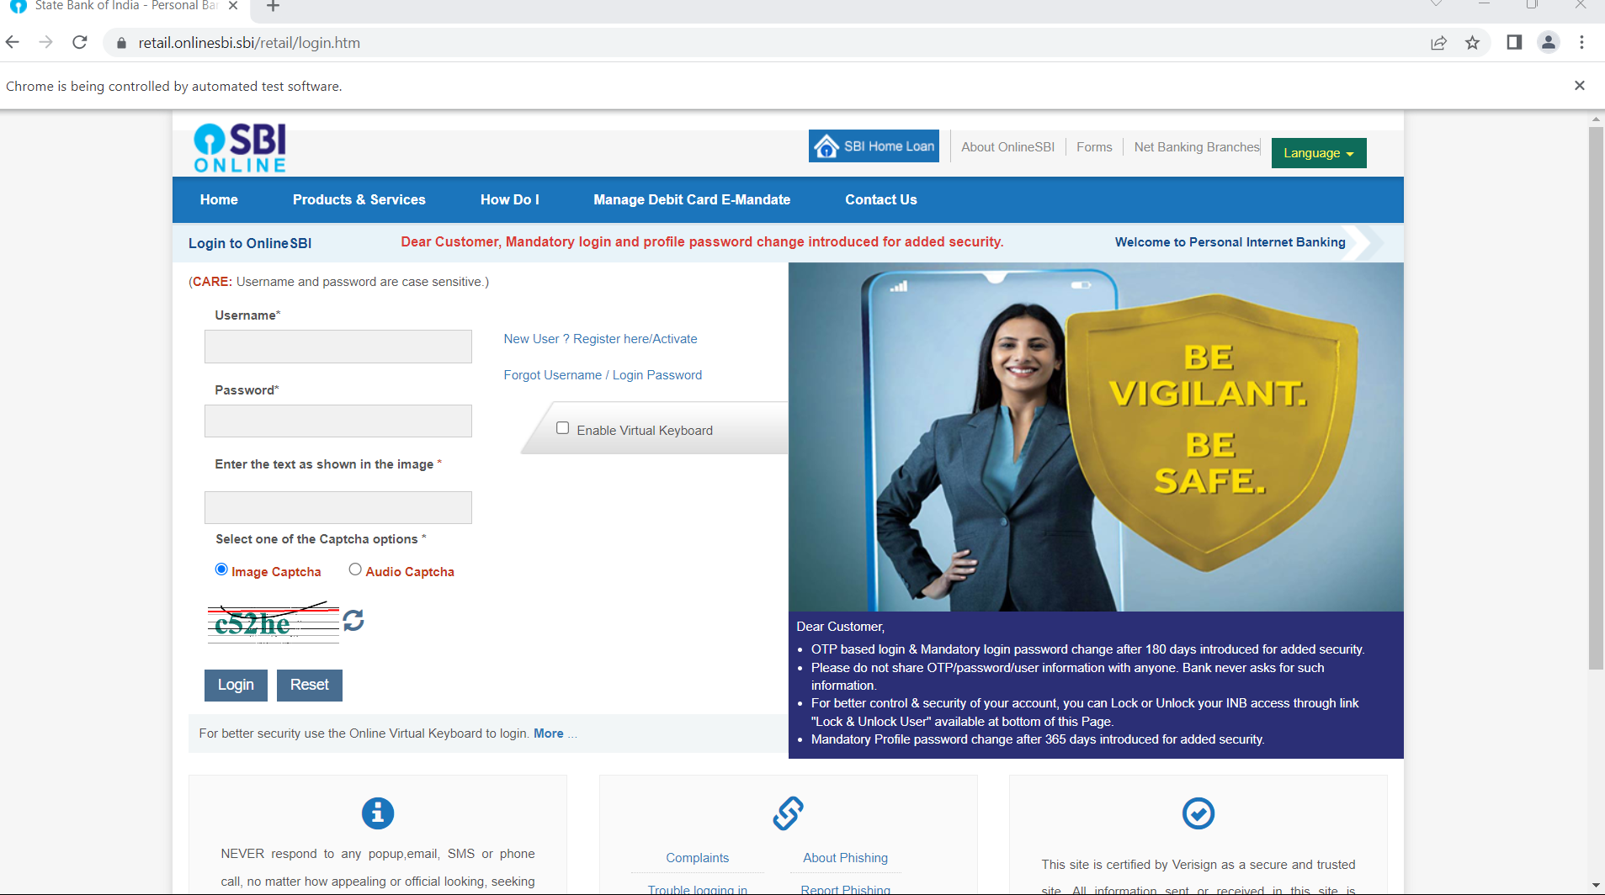

**CalendarDemo:**

package Demo;

import java.util.List;

import org.openqa.selenium.By;

import org.openqa.selenium.WebElement;

import org.openqa.selenium.edge.EdgeDriver;

public class Calendar {

public static void main(String[] args) {

// 1) Open the browser

EdgeDriver driver = new EdgeDriver();

// 2) Maximize it

driver.manage().window().maximize();

// 3) Navigate to application

driver.get("https://www.expedia.co.in/");

// 4) Click on Calendar icon

driver.findElement(By.id("date_form_field-btn")).click();

//5) Select 9th from the next month

WebElement nextMonth = driver.findElement(By.xpath("(//table[contains(@class, 'weeks')])[2]"));

List<WebElement> rows = nextMonth.findElements (By.tagName("tr"));

for (int i = 1; i < rows.size(); i++) {

WebElement row = rows.get(i);

List<WebElement> columns= row.findElements(By.tagName("button"));

for (WebElement x : columns) {

if (x.getAttribute("data-day").equals("9")) {

x.click();

break; // Stop searching rest of the dates by coming out of the for-each loop

}

}

}

// 6) Click on 'Done' to close the calendar

driver.findElement(By.xpath("//button[contains(@data-stid, 'apply-date')]")).click();

}

}

**Output:**

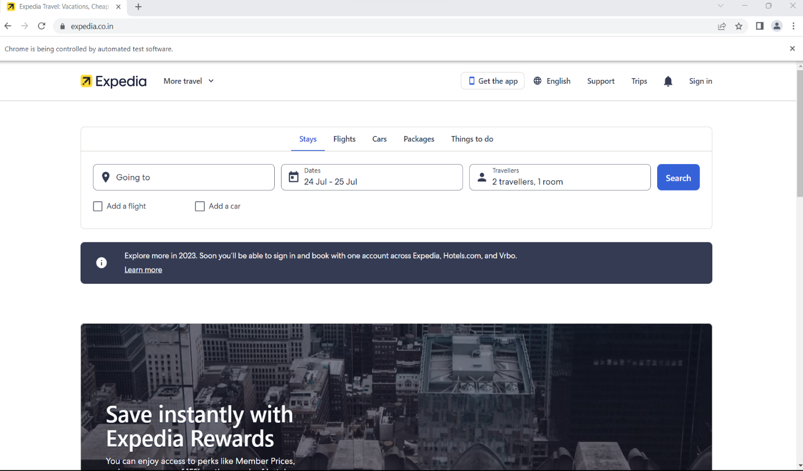

**BrowsweProfiling Demo:**

**package** demo;

**import** org.openqa.selenium.chrome.ChromeDriver;

**import** org.openqa.selenium.chrome.ChromeOptions;

**public** **class** BrowserProfiling {

**public** **static** **void** main(String args[]) {

ChromeOptions options = **new** ChromeOptions();

options.addArguments("--disable-notifications");

ChromeDriver driver = **new** ChromeDriver(options);

driver.manage().window().maximize();

driver.get("https://yatra.com");

}

}

**Output:**

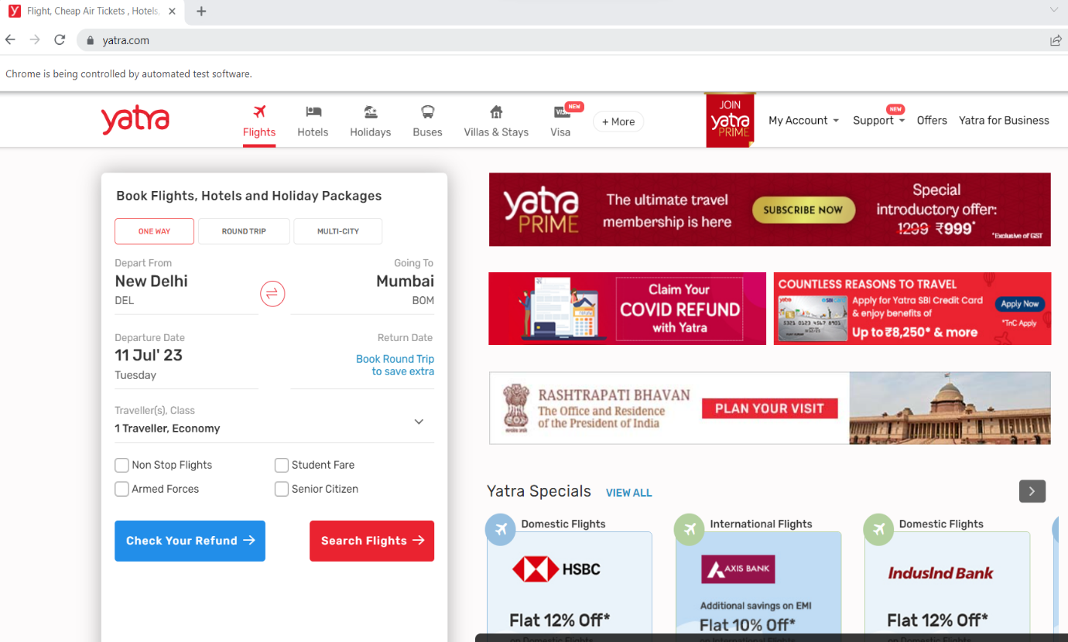

**MouseHoveringDemo:**

**package** demo;

**import** java.time.Duration;

**import** org.openqa.selenium.By;

**import** org.openqa.selenium.WebElement;

**import** org.openqa.selenium.chrome.ChromeDriver;

**import** org.openqa.selenium.interactions.Actions;

**import** org.openqa.selenium.support.ui.ExpectedConditions;

**import** org.openqa.selenium.support.ui.WebDriverWait;

**public** **class** MouseHoveringDemo {

**public** **static** **void** main(String args[]) **throws** InterruptedException {

ChromeDriver driver = **new** ChromeDriver();

driver.manage().window().maximize();

driver.get("https://ebay.com");

WebElement motors = driver.findElement(By.*partialLinkText*("Motors"));

Actions actions = **new** Actions(driver);

actions.moveToElement(motors).build().perform();

WebDriverWait wait = **new** WebDriverWait(driver, Duration.*ofSeconds*(60));

wait.until(ExpectedConditions.*visibilityOfElementLocated*(By.*partialLinkText*("Engines and parts")));

driver.findElement(By.*partialLinkText*("Engines and parts")).click();

}

}

**Output:**

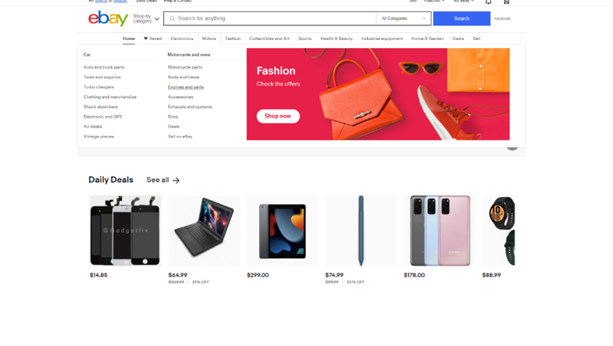

**SwitchingTabs Demo:**

package demo;

import java.time.Duration;

import java.util.ArrayList;

import org.openqa.selenium.By;

import org.openqa.selenium.chrome.ChromeDriver;

import org.openqa.selenium.support.ui.ExpectedConditions;

import org.openqa.selenium.support.ui.WebDriverWait;

public class SwitchingTabs {

public static void main(String args[]) throws InterruptedException {

ChromeDriver driver = new ChromeDriver();

driver.manage().window().maximize();

driver.get("https://www.facebook.com/");

driver.findElement(By.partialLinkText("Instagram")).click();

ArrayList<String> tabs = new ArrayList<>(driver.getWindowHandles());

driver.switchTo().window(tabs.get(1));

WebDriverWait wait = new WebDriverWait(driver, Duration.ofSeconds(60));

wait.until(ExpectedConditions.visibilityOfElementLocated(By.name("username")));

driver.findElement(By.name("username")).sendKeys("abc@gmail.com");

}

}

**Output:**

